CLUBHOUSE REPORT MARCH VOL. 2 ISSUE 3

**The Clubhouse** *by Nikki*

Bridges clubhouse is a beautiful building. This clubhouse has some nice peers. You should know this building has smart counselors and staff. The clubhouse has music. You can learn so many things from the computer. Sitting here thinking what I want to be when I’m a little older .We have good lunches here. If you have never been to Bridges I would challenge you to come. The building is very clean. I can say I keep my hygiene up also. We take good care of the equipment. In my book Bridges is number one. You don’t have to be quick to learn what you need to. Take your time I’m sure you will learn what you come for at Bridges . Bridges has me on my tip toes. I enjoy coming here.



**Facing My Fears**  *by Alex*

One of my fears I faced was dancing in public last Wednesday. I must admit I was scared to death at first. But, one of the counselors inspired me to get out my comfort zone and dance and mingle with the OT interns. So when I heard that I decided to give it a try and dance for the first time ever in public. The moment I started dancing I felt energized and motivated. After a while I faced my fears and started dancing with a lot of people. At first I felt embarrassed and ashamed of myself. I felt that people were going to laugh at me because I didn’t know how to dance. But they said I had the moves and was dancing fine. Then I faced my fears of taking pictures with others. After awhile I felt good and motivated to dance some more. I would like to thank this special counselor for inspiring me and getting me out my comfort zone!.Thank you thank you thank you !!!!



**MEMBER OF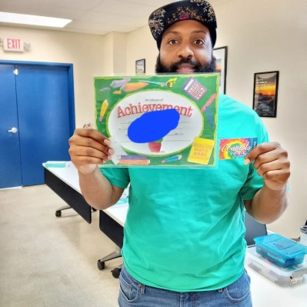 THE MONTH**

**NATE’s FAVORITES**

Food: Neck Bones, Rice and Peas Game: Super Smash Bros Song: Money Talk by TI Movie: Creed Sport: Football Color: Red

**Riverbanks Zoo** *by Johnny*

I went to the zoo and seen a beer lying for a while with hay. I saw a gorilla sleeping while others were playing. Then I saw a komodo dragon. And I saw a giraffe and zebra. Was a great time for a while. Then I saw a train and the petting zoo. A sheep and an alpaca. Then I saw Marshall get a drink. Then I went to hold a drink for James. The trip was about to be over, then we saw flamingos and penguins.

**The Clubhouse** *by Tim*

Clubhouse helps me out very much. I am glad I am here. I have lots of fun. It helps me learn about my illness. I enjoy being here very much. I appreciate the staff helping me with problems. I learn about medication and side effects. I like the food here.

**Zoo Trip** *by Micah*

What I like about the zoo are the animals. Lions, tigers, bears, flamingos, penquins, zebras, elephants and giraffes.

**Bridges** *by Joe*

If you get sick at the clubhouse staff will take care of you. If you are sick before you get to the clubhouse don’t come. I don’t like to stay home. I come here to learn I don’t come to pick a fight. This clubhouse means a lot to us. Without it we wouldn’t have any place to go. Let the staff know you really love the clubhouse. You need to follow the rules and listen to staff.

**Trip To North Carolina** *by Nate*

I was bored working and living alone in my apartment. All of a sudden I got an impulse to take a trip. I gassed up my car with one outfit and hit the road. The trip was enjoyable once I hit the interstate. About three hours later I arrived. I drove around the city for a while. And then went to a beach. Expecting the beach to be crowded with people but it was not. With very few people there I walked along the sand. It was warm and felt good to my feet. I saw two people there and began conversing with them. Even though no one was barely there everything went all right. I was used to being in public, where a crowd was but oh well. I walked out anyway. Afterwards I went to get a room, settled there for the night and left in the morning.